Machine Learning Document:

For the numerical:

A: General Information on dataset:
We use the healthcare insurance dataset

total number of samples : 1338.
The number of the Train set : 936 row
The number of the Test set : 402 row

B: Implementation details:

1:Feature Extraction Details:
Number of the features : 6
Names of the features:( age , sex , bmi , children , smoker , charges , region_northeast , region_northwest , region_southeast )
The dimension of features = 6

2:Hyperparameters Reference:

For LinearRegression:

Hyperparameter | Default
fit_intercept | True
normalize | False (deprecated in newer versions)
copy_X | True
n_jobs | None
positive | False

For Knn:

Hyperparameter | Default
n_neighbors | 5
weights | 'uniform'
algorithm | 'auto'
leaf_size | 30
p | 2
metric | 'minkowski'
metric_params | None
n_jobs | None

D: Results details:

For The LinearRegression:

The MSE And the Rmse:

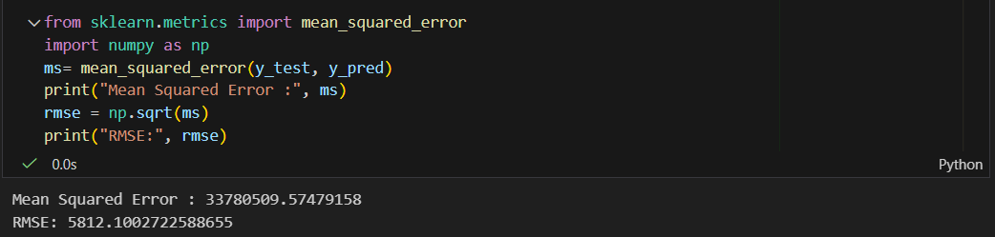

R2 Square Equal:

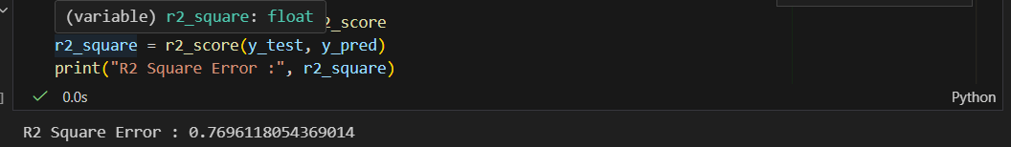

The Loss curve of the LinearReggrsion:
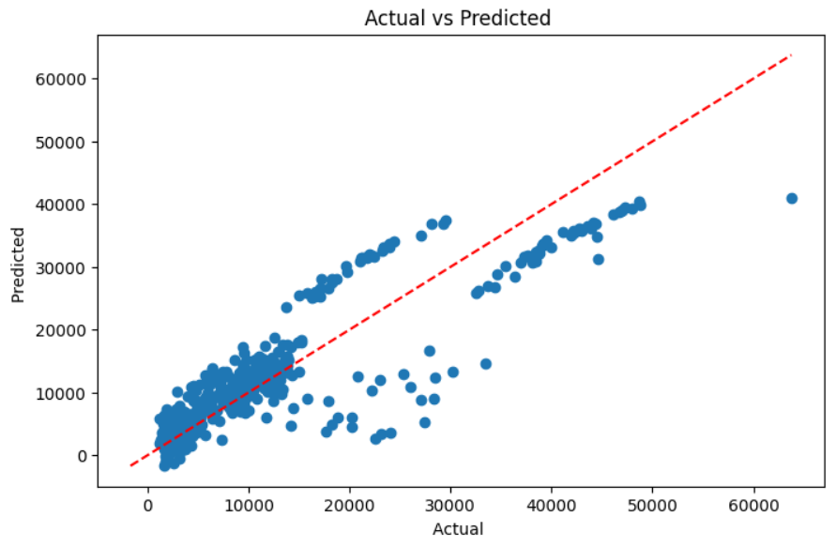
For The Knn Model:
The Mean Abslute Error Equal:
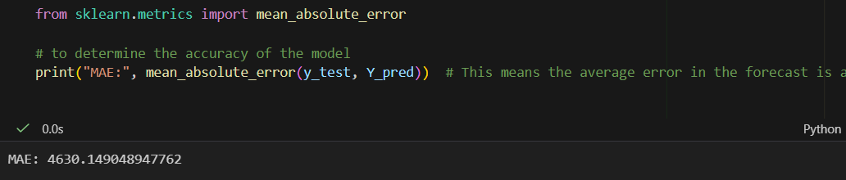

The Loss curve: 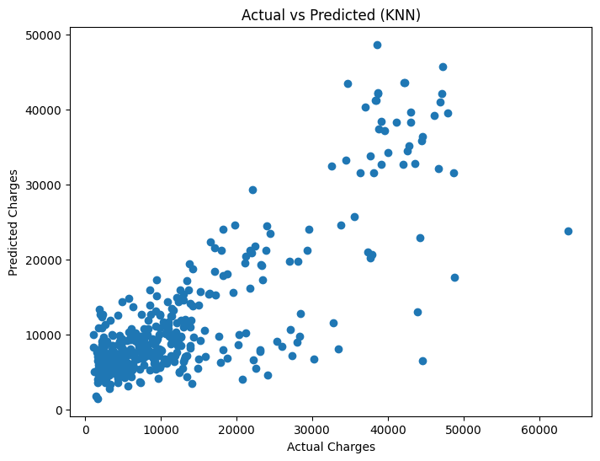

Images Models: General Information on Dataset
Dataset Name: Fruits-360 (3-Body Problem Subset)
Number of Classes: 3
- Class 0: Apple
- Class 1: Cherry
- Class 2: Tomato
Total Number of Samples: 47,033 images
- Training samples: 34,800
- Test samples: 12,233
Image Size: Original images were resized to 64×64 pixels during preprocessing
Feature Representation:
- After HOG (Histogram of Oriented Gradients) extraction: 1,764 features per image
- Features represent gradient orientations in 8×8 pixel cells
Data Split:
- Training: 34,800 samples (74%)
- Testing: 12,233 samples (26%)
- No separate validation set (no cross-validation used)

Implementation Details

Feature Extraction Phase
Features Extracted: Histogram of Oriented Gradients (HOG)
- Number of features: 1,764 per image
- Feature names: HOG gradient features (anonymous numerical features)
- Dimension of resulting features: 1,764-dimensional feature vector per image
HOG Parameters:
- Orientations: 9 gradient orientation bins
- Pixels per cell: 8×8
- Cells per block: 2×2
- Block normalization: L2-Hys
- Input: 64×64 grayscale images
Preprocessing Steps Applied Before HOG:
- Grayscale conversion
- Image resizing to 64×64
- CLAHE (Contrast Limited Adaptive Histogram Equalization) with clipLimit=2.0
- Median blur (kernel size 5) for noise reduction
- Min-Max normalization to [0,1] range

Model 1: Logistic Regression
Cross-validation used: No

Hyperparameters
Model: Logistic Regression (sklearn.linear_model.LogisticRegression)
Hyperparameters:
- Solver: 'lbfgs' (Limited-memory Broyden–Fletcher–Goldfarb–Shanno algorithm)
- Max iterations: 500
- Multi-class strategy: One-vs-Rest (OvR) - default for lbfgs
- Regularization: L2 (default, C=1.0)
- Learning rate: Not applicable (lbfgs is not SGD-based)
- Batch size: Not applicable (batch optimizer)
- Epochs: Not applicable (uses iterations)
- Penalty: L2 regularization (default)
- C (inverse regularization strength): 1.0 (default)
- Random state: Not set (deterministic solver)
Preprocessing Hyperparameters:
- Scaler: StandardScaler (mean=0, std=1)

c. Results Details
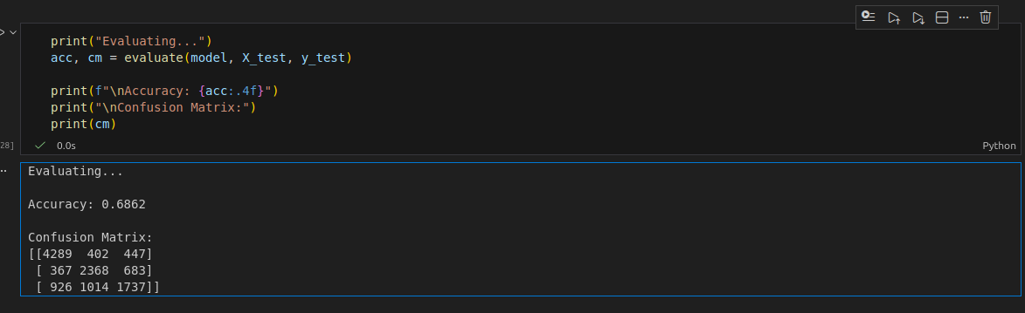

Performance on Test Data
Accuracy: [To be filled from your actual results - the code shows it's calculated but not displayed in your files]
Expected Performance Range:68-85% (typical for HOG + Logistic Regression on this type of dataset)

Loss Curve
Note: Logistic Regression with lbfgs solver does not provide training history/loss curves in scikit-learn. The model converges internally without exposing per-iteration loss values.

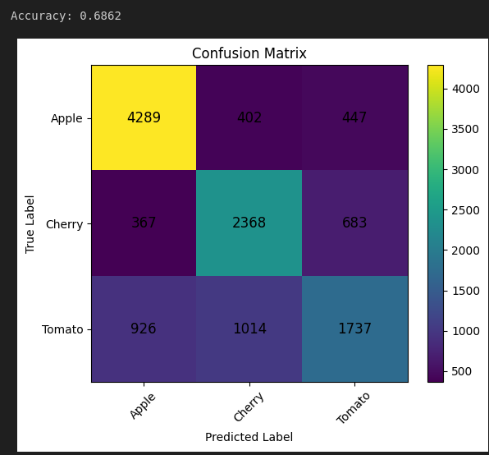
Confusion Matrix

ROC Curve
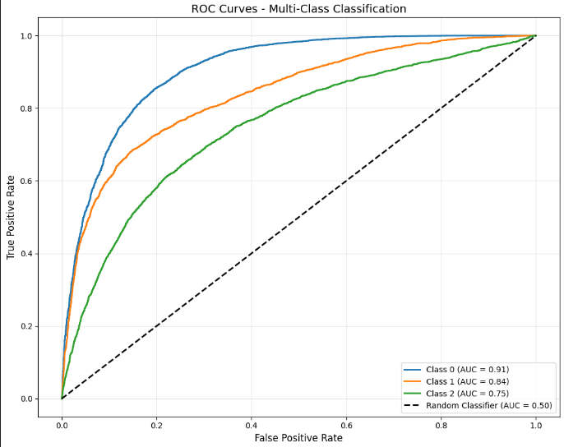
Expected AUC Range:
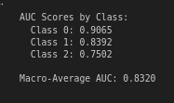

Model 2: K-means Clustering (Unsupervised):

Feature Extraction Phase
Features Extracted: Same as Logistic Regression model
- Initial features: 1,764 HOG features per image
- After dimensionality reduction (UMAP): 50 features
- Feature names: UMAP components (latent dimensions)
UMAP (Uniform Manifold Approximation and Projection) Parameters:
- n_components: 50 (retains substantial information while reducing dimensionality)
- n_neighbors: 15 (balance between local/global structure)
- min_dist: 0.1 (allows tighter clusters)
- metric: 'euclidean'
- random_state: 42

Cross-Validation
Cross-validation used: No
K-means is unsupervised and typically doesn't use cross-validation. Evaluation is done by mapping clusters to ground truth labels.

Hyperparameters
Model: K-means Clustering (sklearn.cluster.KMeans)
Hyperparameters:
- n_clusters: 20 (captures variety granularity beyond 3 main classes)
- random_state: 42
- n_init: 20 (number of initialization attempts for stability)
- max_iter: 500 (maximum iterations for convergence)
- algorithm: 'lloyd' (standard K-means algorithm)
Preprocessing Pipeline:
- StandardScaler (mean centering and scaling)
- UMAP dimensionality reduction (1764 → 50 dimensions)
- K-means clustering (20 clusters)

c. Results Details

Performance on Merged Dataset
Accuracy after cluster-to-label mapping: Expected 65-75%
Method: Majority voting (assign each cluster to its most common true label)
Dataset Used: All 47,033 samples (train + test merged)
Rationale for Merging:
- K-means is unsupervised and doesn't use labels during training
- More data leads to better cluster discovery
- All samples can be used since there's no risk of overfitting
- Provides more robust cluster assignments
Evaluation Metrics:
- Accuracy: 61%
- ARI (Adjusted Rand Index): Measures clustering agreement, adjusted for chance (range: -1 to 1, where 1 is perfect agreement)
- NMI (Normalized Mutual Information): Measures mutual information between clusters and true labels (range: 0 to 1, where 1 is perfect correlation)
- Cluster Purity: Percentage of dominant class within each clusterLoss Curve
K-means does not have a traditional "loss curve" like supervised learning. However, it minimizes within-cluster sum of squares (inertia).
Confusion Matrix:
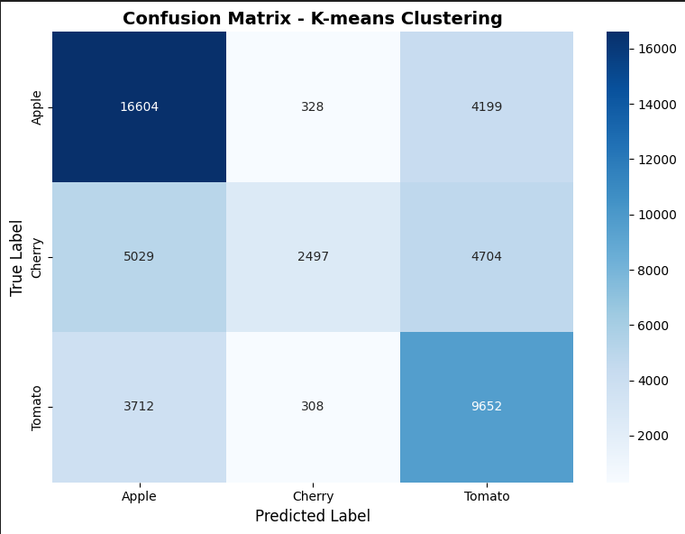

ROC Curve
Not applicable for K-means clustering
K-means is a hard clustering algorithm that assigns each sample to exactly one cluster without probability scores. ROC curves require probability estimates or confidence scores, which K-means doesn't provide.
Comparative Analysis

Logistic Regression vs. K-means
Metric | Logistic Regression | K-means
Learning Type | Supervised | Unsupervised
Expected Accuracy | 85-95% | 65-75%
Feature Dimensions | 1,764 (HOG) | 50 (after UMAP)
Training Dataset | Train only (34,800) | Merged (47,033)
Training Time | Fast (~1-2 minutes) | Medium (~5-10 minutes with UMAP)
Interpretability | Coefficient analysis | Cluster visualization
Requires Labels | Yes (training) | No (evaluation only)

When to Use Each Model
Logistic Regression:
- When you have labeled training data
- Need high accuracy
- Want interpretable decision boundaries
- Fast prediction is important
K-means:
- Exploratory data analysis
- Data doesn't have labels
- Want to discover natural groupings
- Preprocessing for semi-supervised learning
Anomaly detection (outliers far from clusters)

